
Middle East Technical University
Department of Statistics
STAT 365
SAMPLING AND SURVEY
TECHNIQUES
TERM PROJECT
Attention, Digital Behavior, and Academic Outcomes Among METU Students

January 2026
Submitted to Prof. Dr. Burçak Başbuğ Erkan

Timuçin Eke 2549244
Yusuf Özcan 2614782
Dilara Yıldırım 2614907
Kemal Can Yoloğlu 2614915
1. INTRODUCTION 3
1.1 Abstract 3
1.2 Data Description 3
2. Aim of Research 5
2.1 Main Objective 5
2.2 Minor Objectives 6
3. Survey Methodology 6
3.1 Survey Design 6
3.1.1 Sample Design 6
3.1.2 Data Collection 7
3.2 Method Analysis 7
3.2.1 Descriptive Statistics 8
3.2.2 Statistical Tests 8
4. Data Analysis, Findings & Discussions 8
4.1 Research Question 1 9
4.2 Research Question 2 13
4.3 Research Question 3: 15
4.4 Qualitative Findings from Open-ended Questions 18
4.4.1 Factors Reducing Attention During Study 19
4.4.2 Strategies Used to Improve Concentration 20
4.4.3 Overall Interpretation 21
5. Conclusion & Future Works 21
5.1 Conclusion 21
5.2 Future Works 22
6. References 23

1. INTRODUCTION
The learning routines of university students are increasingly being shaped by digital technologies, which affect how students allocate and maintain their attention during their studies. Students today are used to working with technologies that involve extended periods of screen time, frequent interruptions, disruptions from notifications, and multitasking during their study routines. While digital technologies provide flexible and accessible study routines, they also lead to poor concentration, mental exhaustion, and difficulties sustaining attention.
The patterns of student behavior are changing because of the expanding use of Artificial Intelligence (AI) tools. The use of AI by students can be a form of academic support, or AI can be used to completely delegate a responsibility to AI for an assignment, raising concerns about the effects of this technology on students' focus and studying.
This study examines attention-related behaviors, digital study practices, and academic performance of university students based on survey data. The study takes an exploratory approach, focusing on finding relationships rather than causal explanations, and integrating quantitative data with qualitative insights from open-ended questions.

1.1 Abstract
This study analyses the correlation between students' attention levels, their online study activities, and their academic achievement. Data were collected through an anonymous online survey and analysed after a structured data preparation and cleaning process, resulting in a final sample of N = 188 respondents.
The dataset consists of demographic data, self-reported data on academic performance, data on digital behavior, attention-related Likert-scale data, and data from open-ended questions. Descriptive statistics and appropriate categorical and ordinal methods are used to explore associations between attention indicators, digital habits, and academic performance. Furthermore, the qualitative analyses of the responses to the open-ended questions are used to substantiate and give context to the findings from the quantitative data.

1.2 Data Description
The dataset used in this study was obtained through an online survey conducted among university students. The first set of data collection yielded 197 responses. However, after data cleaning and preparation,
responses that had evident inconsistency of data, missing critical values, or responses that did not meet the set quality standards, were removed.
After these procedures, the final dataset consists of N = 188 observations and 18 variables. Structural missing values were preserved where appropriate, particularly for conditional questions that were not applicable to all participants. The cleaned dataset provides a reliable basis for both descriptive and inferential analyses conducted in the study.
The dataset includes variables related to demographic characteristics, academic background, digital behavior patterns, attention-related indicators, and AI tool usage. In addition, various open-ended questions were included to capture students’ subjective experiences, challenges, and strategies related to attention management and screen time regulation.
Variables Included in the Dataset:
variable name | description | scale
Education_Level | Current level of higher education (e.g., undergraduate, graduate) | nominal
Academic_Year | Year of study within the current education level | ordinal
GPA_Range | Self-reported cumulative GPA range | ordinal
Daily_Screen_Time | Average daily screen time in hours | ordinal
Social_Media_Usage | Frequency of social media usage | ordinal
Multitasking_Frequency | Frequency of multitasking during study sessions | ordinal
Notification_Distraction | Level of distraction caused by digital notifications | ordinal
Video_Speed | Preferred playback speed for online videos | ordinal
Screen_Time_Effects_Focus | Perceived effect of screen time on attention | ordinal
Attention_Difficulty | Self-reported difficulty in maintaining attention | ordinal
Mental_Fatigue | Experience of mental fatigue during study | binary
Eye_Strain | Experience of eye strain due to screen usage | binary
Sleep_Disruption | Sleep disruption related to screen exposure | binary
AI_Usage | Use of AI tools for academic purposes | binary
AI_Usage_Frequency | Frequency of AI tool usage | ordinal
AI_Usage_Purpose | Main purpose of AI usage (supportive assistance vs task delegation) | nominal
Attention_Reducing_Factors | Factors that reduce attention during study sessions (open-ended) | text
Concentration_Strategies | Strategies or habits that help boost concentration (open-ended) | text

2. Aim of Research
The aim of this study is to analyse the relationship between university students’ attention levels, digital study behaviors, and academic performance in a modern academic context. With the growing integration of technology into the study behaviors of university students, issues such as extended screen time usage, multitasking, notifications, and the use of AI-based tools have become central to students’ learning experiences.
Instead of attempting to establish causal relationships, this research adopts an exploratory approach. The primary focus is on identifying associations between attention-related indicators, digital habits, and academic outcomes using survey data. In addition, the study includes students’ subjective experiences through open-ended responses in order to provide a more comprehensive understanding of attention management in digital learning environments.

2.1 Main Objective
The main objective of this study is to investigate how attention-related factors and digital study behaviors are associated with academic performance among university students. Especially, the study investigates the relationship between daily screen time, frequency of multitasking, distraction due to notifications, use of AI tools, and the self-reported loss of points due to lack of attention.

2.2 Minor Objectives
In addition to the main objective, the study also pursues the following minor objectives:
- To explore the relationship between the behavior of study habits chosen digitally and attention strain among students.
- To examine the relationship between the frequency of multitasking and the perceived capacity of the students to resume attention following distraction.
- To determine the correlation between the ability to sustain focus and academic mistakes associated with attention.
- To determine typical reasons behind loss of attention and strategies used by the participants in self reporting to improve focus.
- To provide a combined interpretation of both quantitative and qualitative results.

3. Survey Methodology

3.1 Survey Design
This study uses a cross-sectional survey design to explore associations between university students’ attention-related behaviors, digital study habits, and academic performance. The questionnaire was administered using Google Forms and includes (i) demographic and academic background questions, (ii) digital behavior indicators such as screen time, multitasking, distraction by notifications, usage of AI tools, (iii) attention-related Likert-type items, and (iv) two open-ended questions focusing on attention-reducing factors and concentration strategies. The survey was designed to be concise in order to encourage participation and to reduce the impact of survey fatigue.

3.1.1 Sample Design
The target population of the study is university students. The collection of data was done in a mixed approach that can be considered as convenience based. Approximately 80% of the data was gathered using direct contact with students with the aid of in-person data collection on campus. Students were approached in common university areas and were given the option to respond on a voluntary basis after being given a QR code that linked them to the survey.
In addition, the survey link was shared with students in the researchers’ extended academic and social networks to increase participation. While efforts were made to approach students from different faculties and academic years, the sample does not reflect a totally random sample. After data screening and cleaning procedures, the final analytic dataset consists of N = 188 respondents. Therefore, the sample is suitable for descriptive analysis and exploratory investigation of associations.

3.1.2 Data Collection
An anonymous Google Forms survey was used for data collection. Before starting the survey, participants were informed of the study’s objectives and that their participation was voluntary. To protect confidentiality, no identifying information was collected from participants.
All responses were recorded electronically. After the data collection, the dataset was exported and processed using R for data cleaning, preparation, and subsequent statistical analysis.

3.2 Method Analysis
All data preparation, descriptive analysis, and statistical procedures in this study were conducted using the R programming language. The analytical techniques were selected based on the measurement levels of variables and the exploratory characteristics of research objectives. Categorical and ordinal variables were summarized using frequency-based approaches, while appropriate association analyses were applied to examine relationships between attention-related variables, digital behaviors, and academic performance.
Given that the study does not aim to establish causal relationships, the analysis focuses on identifying meaningful patterns and associations within the collected survey data. To complement and conclude the quantitative outcomes, the open-ended questions were analysed using qualitative descriptive methods.

3.2.1 Descriptive Statistics

The descriptive statistics were applied to provide the overview of the sample characteristics and summarize the distribution of the main variables of attention-related and digital behaviors before the inferential analysis.

The items of attention strain, sustained focus ability, regain-focus ability, and attention related academic mistakes were ordinal variables that were summarized as Likert-type items. Distributional patterns and central tendency were considered to facilitate interpretation of the consequent non-parametric analysis instead of assuming distributions.

In order to visually support the descriptive interpretation, response distributions of categorical variables were presented in bar charts created in R, and heatmaps and visuals of boxplots were created to present distributional patterns within ordered categories where suitable. These visualizations of description were done to show patterns of responses that were dominant and the monotonic trends as opposed to the specific group comparisons.

In general, descriptive statistics and visual summaries were used as a background to comprehend students in terms of their digital study patterns, attention experiences, and academic performance.

3.2.2 Statistical Tests

To address the exploratory study goals, inferential analyses were done to investigate the relationship among attention-related variables, digital study behaviors, and academic outcomes. Since most of the variables were measured at the ordinal level and the majority of the variables were not observed to be normally distributed, non-parametric statistical tests were used in the throughout analysis.

To determine the existence of monotonic relationships, association tests between ordinal outcome and ordered predictors were measured by Spearman rank-order correlation tests. Kruskal-Wallis tests were the main forms of inference for comparisons of attention strain across different ordered behavioral categories. In appropriate situations, ordinal trend analyses were used to further investigate systematic increasing or decreasing trends in ordered groups.

When analyzing the relationship among categorical variables, contingency table based analyses such as chi-square tests of independence were employed. In cases where expected cell counts were small, exact methods were considered to ensure the robustness of statistical inference.

All statistical tests were performed at 0.05 of significance level. Findings are interpreted within an exploratory context and discussed in concerning the observed patterns of distribution and research question as opposed to being the evidence of causal impacts.

4. Data Analysis, Findings & Discussions

4.1 Research Question 1
What digital behavior patterns are associated with students’ attention strain?
This section examines the association between attention strain of students and selected digital behavior patterns. Attention strain was measured using a composite Attention Strain Index, where higher values indicate greater levels of attentional difficulty. Due to the ordinal nature of the predictor variables and the non-normal distribution of the outcome variable, Kruskal-Wallis tests were used as the primary inference method.
Variables Used
Dependent Variable: The Attention Strain Index was constructed as a composite score by combining three 5-point Likert items:
- Mental fatigue during study (mental_tired_likert)
- Disruption caused by notifications (notifications_break_likert)
- Ability to focus for 30 minutes (focus_30min_likert)
All items were first converted to numeric values (1–5). Since higher focus indicates lower strain, the focus item was reverse-coded to align directionality:
$$\text{focus rev}=6-\text{focus 30min likert}$$
The index was then computed as the row-wise mean of the three aligned components:
$$\text{Attention Strain Index}=\frac{\text{mental tired}+\text{notifications break}+\text{focus rev}}{3}$$If a participant had missing data on one component, the index was calculated using the available items (row-wise mean with na.rm = TRUE). Higher values indicate greater attention strain.
Independent Variables (Digital Behaviors)
- Multitasking frequency
- Daily screen time
- AI use frequency
Methods: Given the ordinal nature of the digital behavior variables and supported by preliminary assessments that show deviations from normality, non-parametric statistical methods were used.
The following analyses were used:
- Kruskal–Wallis tests to compare attention strain levels across ordered categories.
- Ordinal trend analysis (numeric rank regression) to determine monotonic relationships.
- Boxplot visualizations to support interpretation of group differences.
All analyses were conducted at a significance level of α = 0.05.
Results: Multitasking Frequency and Attention Strain
A statistically significant association was found between multitasking frequency during study sessions and attention strain (χ²(4) = 10.59, p = 0.032). As shown in Figure 4.1.1, students who reported more frequent multitasking had higher median attention strain scores.
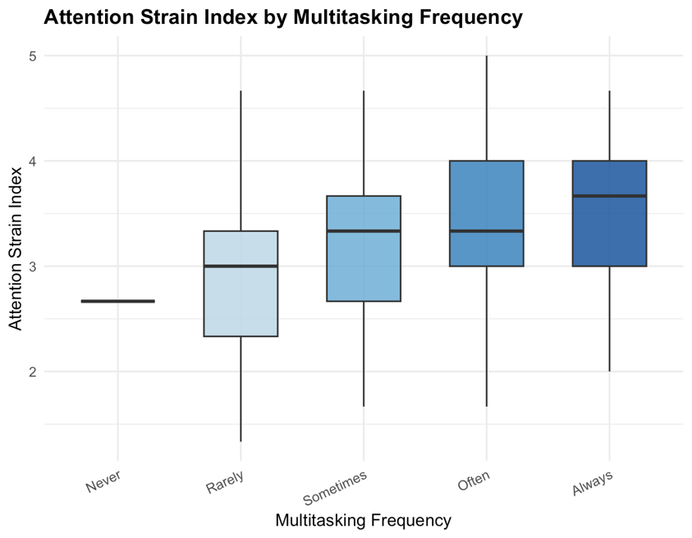
The distributional pattern indicates that when multitasking becomes more frequent there is a systematic increase in attention strain, this suggests that engaging in multiple tasks can introduce additional cognitive load and reduce attentional stability during academic activities.

Figure 4.1.1. Attention Strain Index by Multitasking Frequency
As Figure 4.1.1 shows a clear increase in attention strain as multitasking frequency rises.
Students who multitask more frequently exhibit higher median attention strain scores, with greater variability observed in the “Often” and “Always” groups.
This visual pattern is consistent with the statistically significant Kruskal–Wallis result, indicating that frequent multitasking is associated with advanced attention strain.

Daily Screen Time and Attention Strain
On the contrary, there was no significant relationship between attention strain and total daily screen time. The contingency table analysis did not provide statistically significant correlation between the categories of the daily screen time and the level of attention strain (χ 2 (8) = 5.16, p = 0.740; Fisher exact p = 0.775).
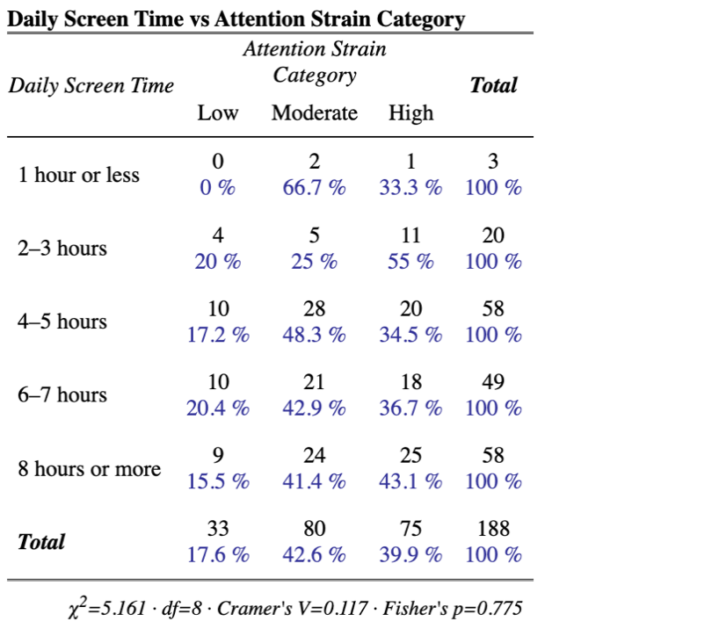

Figure 4.1.2. Attention Strain Index by Daily Screen Time

As Figure 4.1.2 demonstrates, the proportion of categories of attention strain do not vary much among the levels of daily screen time. The relative numbers of students with low, moderate and high attention strain at each category of the screen time do not vary sharply, there is no obvious pattern of gradually increasing or reducing numbers as the screen time increases.
These findings suggest that the amount of time spent on screens alone does not meaningfully differentiate attention strain levels among students. Instead, it is possible that both low and high daily screen time students have similar levels of attentional difficulty, which means that quantity of screen time is a weak predictor when taken alone in the absence of patterns of use.
It should also be noted that the lowest screen time category (1 hour or less) has a rather small number of observations, which can also result in unstable percentage estimates. Thus, the outcomes of this population group should be viewed carefully.
Overall, the analysis of the contingency table proves the conclusion that the number of screen time hours per day is not a strong determinant of attention strain, which supports the view that the use of digital tools might be more significant than the duration of their use.
AI Use Frequency and Attention Strain
Attention strain was found to differ significantly across levels of AI tool use (χ²(4) = 9.96, p = 0.041). To further examine whether this association follows a systematic pattern, the frequency of AI use was treated as an ordered numerical rank, and an ordinal trend model was estimated.
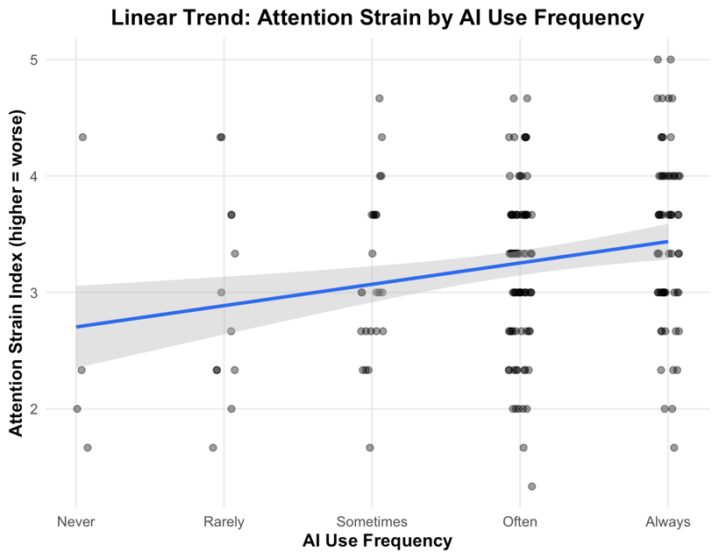

Figure 4.1.3. Linear Trend of Attention Strain Index by AI Use Frequency
Figure 4.1.3 presents the linear trend between AI use frequency and the Attention Strain Index. The fitted regression line shows a clear positive slope, indicating that attention strain increases monotonically as the frequency of AI tool use increases. The estimated trend coefficient was positive and statistically significant (β = 0.183, p = 0.001), providing strong evidence of a monotonic relationship.
This pattern indicates that students who report that they use AI-based academic tools more often tend to experience higher levels of attention strain. Rather than rapid differences between discrete categories, the pattern reflects a gradual and systematic increase in attentional difficulty from “Never” to “Always” users.
The observed linear trend is consistent with the significant Kruskal–Wallis test result and supports the interpretation that frequent AI tool use is associated with increased attention strain. These results suggest that the level of AI engagement, rather than its existence, plays an important role in shaping attentional experiences of students.
Interpretation of Findings:
When the results are combined, they show that attention strain is more strongly associated with behavioral patterns of digital interaction than with overall screen exposure. Frequency of multitasking and frequency of AI use showed a significant association with increased attention strain, while total daily screen time did not show such an association.
These findings support the view that how digital tools are used, rather than how long they are used, plays a more critical role in shaping attention outcomes. Behaviors that divide attention among multiple sources appear to result in increased attention strain among students.
Summary of Key Findings:
- Multitasking frequency is significantly associated with higher attention strain.
- Total daily screen time shows no significant association with attention strain.
- AI use frequency shows a significant positive and monotonic relationship with attention strain.

4.2 Research Question 2
Is multitasking frequency associated with students’ ability to regain focus after distraction?
This part looks at how often students multitask while studying and how well they think they can get back on track after being distracted. Since both these factors are ranked in order and the results aren't spread out, we used special correlation methods that don't assume a normal distribution.
Variable Role | Variable Name | Measurement Type | Scale / Levels | Description
Independent Variable | Daily Screen Time (screen_time_daily) | Ordinal (Categorical) | 1 = 1 hour or less  2 = 2–3 hours  3 = 4–5 hours  4 = 6–7 hours  5 = 8 hours or more | Self-reported average daily screen time. Categories reflect increasing duration of screen exposure.
Dependent Variable | Attention Strain Category (strain_cat) | Ordinal (Categorical) | Low  Moderate  High | Categorical classification derived from the Attention Strain Index. Higher categories indicate greater levels of attention strain.

Methods: Preliminary data screening revealed that the “Never” category of multitasking contained only one observation. Since Spearman's rank-order correlation is based on ranked data and not group means or distributional assumptions, this observation was retained within the inferential analysis as to maintain the full sample size. However, given its very small size, this category was excluded from group-based descriptive summaries and graphical displays in order not to result in unstable or potentially misleading visual representations of the data.
All analyses were conducted at a significance level of α = 0.05
Results: Indeed, a Spearman rank-order correlation analysis showed that the correlation between multitasking frequency and regain-focus ability was significantly positive. The finding meant that students who multitasked more were also those who perceived that they could regain focus more frequently. However, the degree of the association indicated a small to moderate magnitude of the relationship; that is, although frequency of multitasking is a determinant of the regain focus ability, it accounts for a small part of the variance in students’ attentional recovery perceptions.
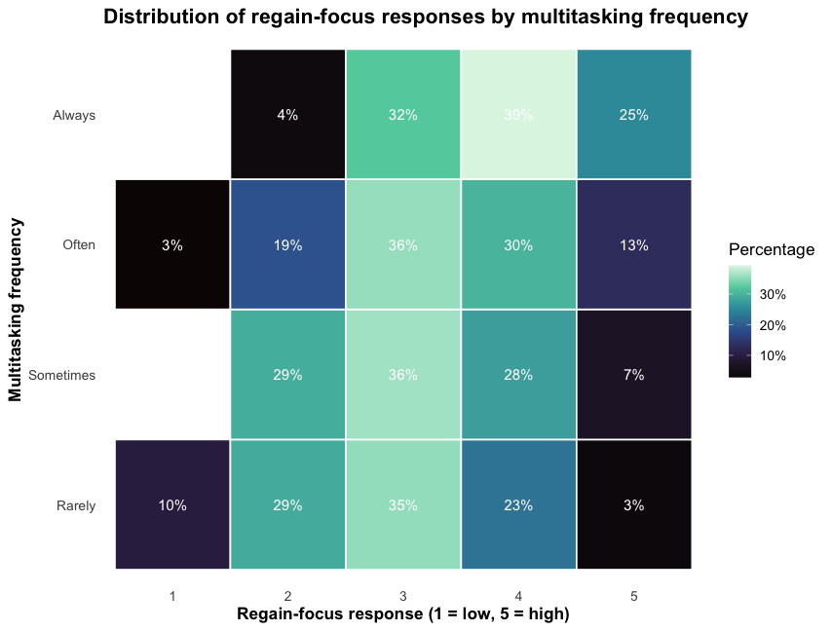
Figure 4.2.1. Ability to Regain Focus by Multitasking Frequency
Figure 4.2.1 showing the distribution of the responses for regain focus by frequency of multitasking. The graph reveals the percentage of students who chose each response for regain focus by the frequency of multitasking.
This heatmap shows a distinct distribution pattern where higher multitasking frequencies are correlated with a higher concentration of higher regain-focus responses (level 4 and 5 responses). On the contrary, lower multitasking levels are found to have a comparatively higher proportion of lower and mid-regain-focus responses. Although all multitasking levels present responses throughout the entire Likert scale, the proportion of higher regain-focus responses steadily and monotonically improves as the frequency of multitasking levels increase.
This is consistent with the positive Spearman correlation result. This pattern also supports the existence of a monotonic relationship in terms of multitasking rates versus regain focus ability.
Interpretation of Findings:
It seems that students who are involved in multitasking activities more often in a study session might be susceptible to developing or feeling they have a better ability to recover their attention after being distracted. This is because of adaptations to strategies based on their personal adaptation to switching attentions, as well as self-selection in terms of their capability to multitask.
However, it should be pointed out that the above analysis is correlation-oriented rather than cause-and-effect-oriented in its nature. Accordingly, implications for causation are not possible, and third variables such as individual cognitive control, learning strategies, and task demands may influence this correlation.
Summary of Key Findings:
- Multitasking frequency is significantly and positively associated with the ability to regain focus after distraction.
- The observed relationship is small to moderate in magnitude.
- Heatmap visualizations indicate an increasing concentration of higher regain-focus responses with greater multitasking frequency.
- The distributional pattern supports a monotonic association between multitasking frequency and regain-focus ability.
- Due to the correlational design, causal interpretations are not warranted.

4.3 Research Question 3:
Is students’ ability to stay focused for more than 30 minutes associated with a reduced likelihood of losing points due to inattention?
In this section, we explore the relationship between students' sustained attention ability and attention-error aspects in their schoolwork. Sustained attention means students' self-reported ability to continuously focus their attention on one thing for over 30 minutes. On the other hand, attention errors reflect how frequently students have missed points in class due to inattention. In both aspects, the variables are ordinal in nature and are non-normal distributed. Hence, non-parametric correlation tests were used

Variable Role | Variable Name | Measurement Type | Scale / Levels | Description
Independent Variable | Sustained Focus (focus_30min_likert) | Ordinal (Likert-type) | 1 = Strongly Disagree  2 = Disagree  3 = Neutral  4 = Agree  5 = Strongly Agree | Self-reported ability to stay focused on a single task for more than 30 minutes. Higher values indicate better sustained attention.
Dependent Variable | Attention-Related Mistakes (lose_points_likert) | Ordinal (Likert-type) | 1 = Strongly Disagree  2 = Disagree  3 = Neutral  4 = Agree  5 = Strongly Agree | Frequency of losing points or making mistakes due to inattention. Higher values indicate more frequent mistakes.

Methods: Preliminary normality checks with the Shapiro–Wilk test showed a serious violation from normality for both sustained focus ability and attention-related mistake scores, p < 0.001. Since the measurement level for the variables is ordinal and the assumptions about normality are violated, a Spearman rank-order correlation has been chosen as the main inferential method to test the presence of a monotonic relationship.
Boxplot visualizations were also examined to illustrate how attention-related mistake scores vary across different levels of sustained focus and support the interpretation of this association.
All analyses were conducted at a significance level of α = 0.05.
Results: The Spearman Rank-Order Correlation test revealed that there was a significant negative correlation between the students' ability to maintain their attention and attention-based errors in academics (ρ = -0.178, p = 0.014). This indicates that those students who were able to maintain their focus for more than 30 minutes were less likely to make errors in terms of losing points or making mistakes due to inattention.
The strength of correlation was small to moderate, signifying that sustained attention is a relevant dimension but certainly not a solitary determinant in error limits for attention.

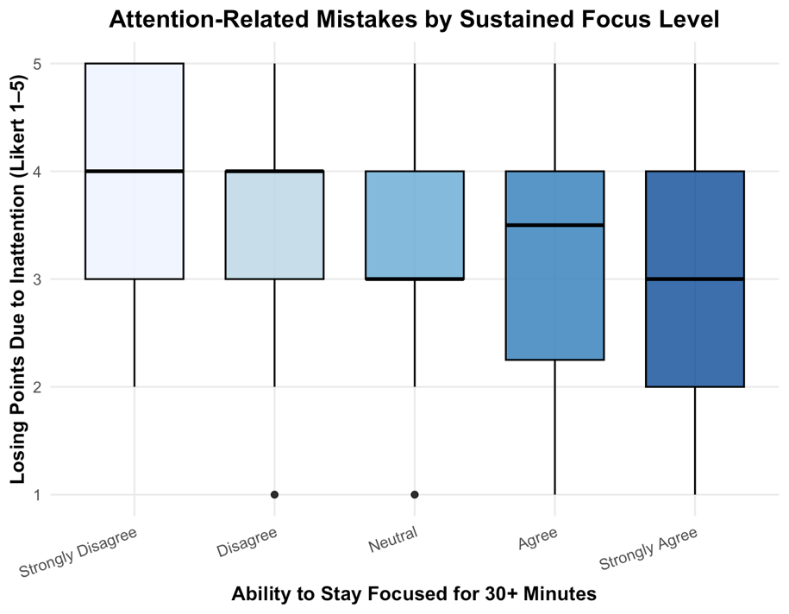

Figure 4.3.1. Attention-Related Academic Mistakes by Sustained Focus Level
Figure 4.3.1 illustrates the distribution of attention-related academic error scores for different levels of sustained attention abilities. The box plot indicates that while students with low sustained attention abilities have large error scores measured from the center of the distribution, students who have high attention abilities have low error scores.
Although there is a great deal of overlap between categories for focus, there is a general distribution pattern from which one might infer a decreasing trend in attention-related mistakes as sustained focus is increased. There is variability evident, despite this variability existing within each focus designation.
"This graphical pattern is consistent with the negative Spearman correlation test result and indicates the existence of a monotonic relationship between sustained focus ability and attention error scores."
Interpretation of Findings:
Collectively, the results indicate that sustained attention ability is correlated with reduced attention-related academic mistake in college students. The more capable students who can be able to concentrate longer seem to be less likely to lose marks because of lack of attention.

This negative correlation is consistent with the "vigilance decrement" phenomenon first described by Mackworth (1948), which established that the level of detection accuracy declines significantly after about 30 minutes of uninterrupted observation. The results indicate that students who cannot sustain their focus beyond this 30-minute limit tend to be more vulnerable to this decline, which leads to an increased number of mistakes.

Moreover, these results are consistent with the findings of Stern and Shalev (2013), who proved that those students who can sustain their attention levels better commit fewer cases of "commission errors" (incorrect responses due to lack of focus) on cognitive tasks. The process involved in this relationship can be described with the help of the "mind wandering": according to Smallwood and Schooler (2015), when students are not able to maintain focus, chances are higher that their minds will lose connection with the task at hand (e.g., the exam paper), thus making them commit careless errors in spite of having the needed knowledge.

Importantly, this finding is a complement to the previous results of Sections 4.1 and 4.2. Although the common practice of multitasking and other digital practices was correlated with higher levels of attention strain, some long-term focus capacity seems to alleviate some adverse academic outcomes of the challenges.

However, it must be noted that it is a correlational analysis. This leads to inability to form causal interpretations, and the observed association can be affected by factors that are not measured, including strategies in a study, task difficulty or individual differences in cognitive control.
Summary of Key Findings:
- The ability of sustained focus is found to be strongly and negatively related to academic mistakes in terms of attention.
- The students who report more sustained focus also lose points because of inattention less often, consistent with the theoretical framework of the "vigilance decrement" (Mackworth, 1948).
- The observed relationship is small to moderate in magnitude.
- Boxplot visualizations support a monotonic decrease in mistake scores as sustained focus increases.
- Due to the correlational design, causal conclusions cannot be drawn.

4.4 Qualitative Findings from Open-ended Questions
This section describes qualitative results from open-ended survey questions on factors that decrease attention and strategies that improve focus. Responses were examined using a thematic approach based on word frequency after performing standard text preprocessing.
To ensure clarity and avoid redundancy, thematic comparisons are shown using bar charts. For their emphasis, students are represented using a single filtered word cloud visualization that shows the most prominent words.

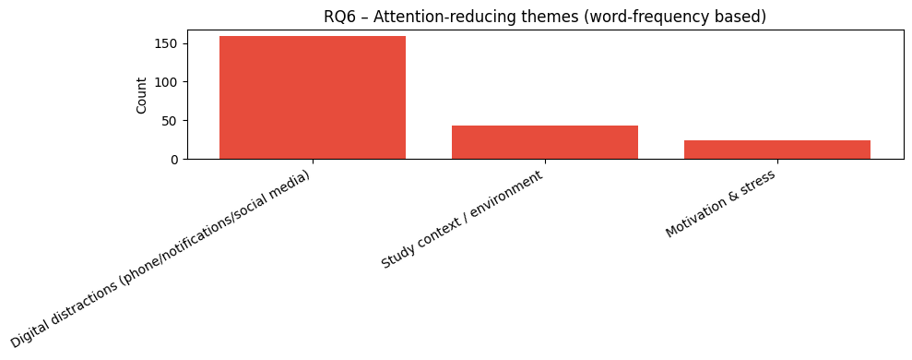
4.4.1 Factors Reducing Attention During Study
Figure 4.4.1. Attention-reducing themes identified from open-ended responses (word-frequency based).
In Figure 4.4.1, the focus is on the dominant themes from the feedback of students on factors that decrease their focus while studying. The most common of these is digital distractions (phone/notifications/social media), which has a larger count than any of the other themes combined. Students frequently mentioned smartphones, notifications, messaging applications, and social media platforms as primary sources of distraction during study sessions.
The second most common theme is study context / environment, where the contributions from external factors like noise and crowded places and environments, and unsuitable places where studying is being done, are acknowledged. Although not as large as the digital distractions, some contribute the loss of attention to surrounding or available environmental factors.
Finally, motivation and stress emerge as a smaller but significant category, reflecting students’ experiences with stress, boredom, mental fatigue, and lack of motivation while studying.

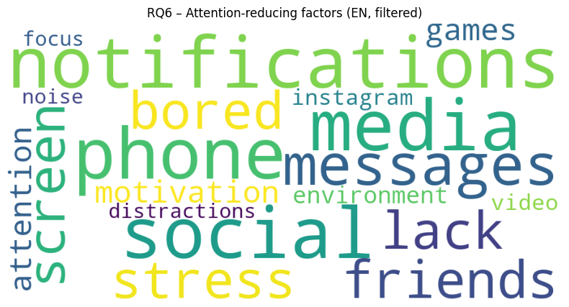

Figure 4.4.2. Word cloud of attention-reducing factors derived from English open-ended responses.
To further illustrate how students describe attention-related problems, Figure 4.4.2 presents a filtered word cloud generated from English responses only, displaying the most outstanding terms after removing generic and non-informative words. The prominence of terms such as notifications, phone, social media, messages, and stress strengthens the thematic findings and highlights the central role of digital technologies in attention reduction.

4.4.2 Strategies Used to Improve Concentration
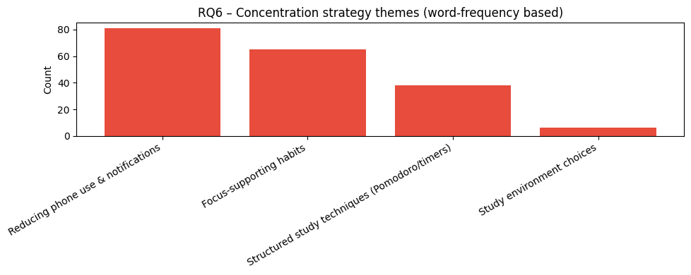Figure 4.4.3. Concentration strategy themes identified from open-ended responses (word-frequency based).
Figure 4.4.3 shows the main themes identified in responses of students regarding strategies used to improve concentration. The most frequently mentioned strategy is reducing phone use & notifications, including behaviors such as silencing notifications, putting the phone out of reach and social media usage reduction while studying.
The second most prominent category, focus-supporting habits, includes practices such as listening to music, taking short breaks, and personal routines for maintaining concentration. Additionally, structured study techniques (pomodoro/timers) appear as a common method for organizing study time and sustaining focus.
In contrast, study environment preferences, such as studying in libraries or quiet spaces, are mentioned less frequently, this suggests that students prioritize behavioral and self-regulation strategies rather than changes in physical study environments.

4.4.3 Overall Interpretation

Overall, qualitative findings indicate that the primary source of attention loss is digital distractions, and that the most frequently reported concentration strategies among students directly target these distractions through behavioral regulation and time management techniques.

The alignment between reported problems (e.g., notifications, phone use, social media) and adopted strategies (e.g., limiting phone access, silencing notifications, using timers) indicates that students have a high level of awareness regarding attention problems and and coping mechanisms.

These qualitative findings provide contextual support to the quantitative results presented in previous sections of the study and contribute to a more comprehensive understanding of attention and academic performance among university students.

5. Conclusion & Future Works

5.1 Conclusion
This study investigates the relationships between attention-related characteristics of university students, digital study behaviors, and academic outcomes using an exploratory, survey-based approach. This work provides a comprehensive picture of how attention and digital habits intersect in modern academic environments.
The findings suggest that attention-related outcomes are more strongly associated with patterns especially, frequent multitasking and higher AI tool usage were both associated with improved attention strain, whereas total daily screen time alone did not exhibit a significant relationship with attentional difficulty. These results indicate that how students busy with digital technologies plays a more crucial role than how long they are exposed to screens.
In addition, the analysis clarified that multitasking frequency is positively associated with perceived ability to regain focus of students after distraction. This result suggests that the frequency of multitasking correlates positively with how the students rate themselves in terms of their capacity to focus again after being distracted. At the same time, constant focus ability was found to be negatively associated with attention-related academic mistakes, indicating that students who can maintain attention for longer periods tend to experience fewer mistakes or point losses due to lack of attention.
The qualitative findings further strengthened these results by underlining digital distractions-particularly smartphones, notifications, and social media-as the dominant sources of attention loss. Importantly, students’ reported concentration strategies largely targeted these same factors, indicating a high level of awareness regarding attention challenges and self-regulatory coping mechanisms. These patterns may also reflect the demanding nature of the academic environment.
In general, the results emphasize that attention in academic contexts is a multifaced construct shaped by behavioral patterns, cognitive habits, and digital environments. While the study does not determine casual relationships, it indicates valuable exploratory evidence on how attention strain, focus recovery, and academic performance are interconnected among university students.

5.2 Future Works
- The study was carried out using cross-sectional, self-reported data. Future studies may operate longitudinal designs that follow the same students over time to explore how focus and digital behavior evolve.
- More accurately assess casual relationships with the use of experimental or quasi-experimental designs. For example, the effect of attention and academic performance could be measured through the use of interventions such as notification limitations or reduced multitasking could be performed to examine their effects on attention and academic performance.
- In future studies, more objective data, such as behavioral attention tasks, academic records, and learning analytics, in addition to self-reported data may be used to minimize response biases.
- The impact of individual differences may be discovered in greater detail. Cognitive control, study strategies, academic discipline, and personality features may be some of the potential moderators of the relationship between digital behaviors and attention outcomes.

6. References
Mackworth, N. H. (1948). The breakdown of vigilance during prolonged visual search. Quarterly Journal
of Experimental Psychology, 1(1), 6-21. https://doi.org/10.1080/17470214808416738

Smallwood, J., & Schooler, J. W. (2015). The science of mind wandering: Empirically navigating the
stream of consciousness. Annual Review of Psychology, 66, 487-518.
https://doi.org/10.1146/annurev-psych-010814-015331

Stern, P., & Shalev, L. (2013). The role of sustained attention and display medium in reading
Comprehension among adolescents with ADHD and without it. Journal of Learning
Disabilities, 46(2), 128-141. https://pubmed.ncbi.nlm.nih.gov/23023301/

